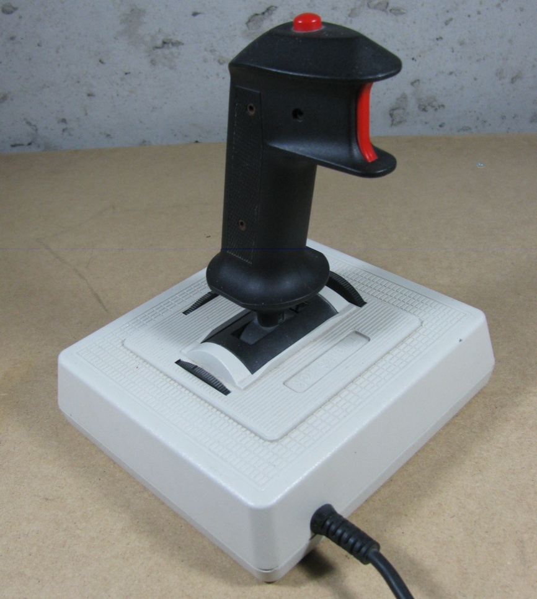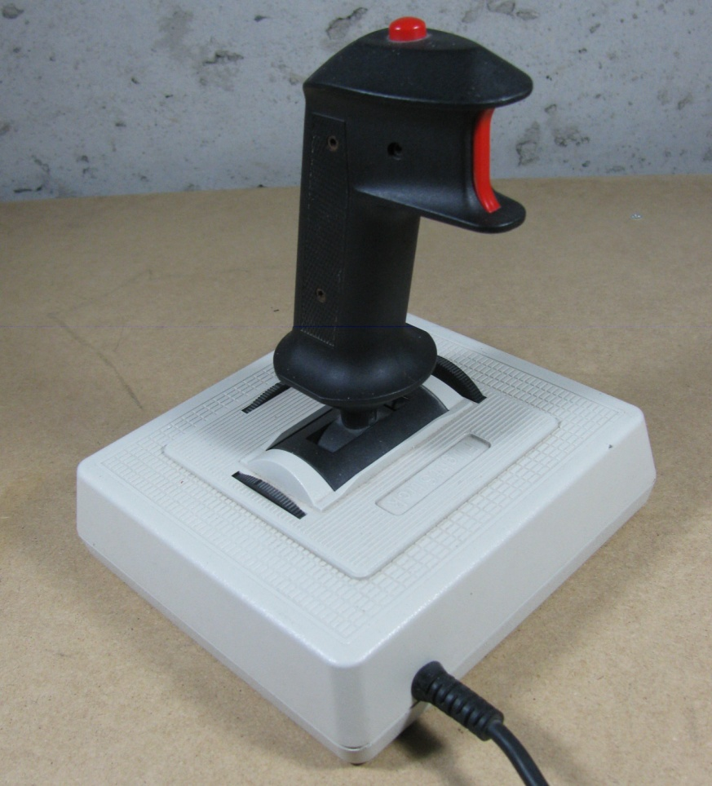

B1: Hold –

Force low gear

B2: Hold –

Hold in place

\

Must be Manual Shifting

Both: Toggle Manual Shift

Shift Down

Shift Up

Left Joystick

Left Joystick

Right Joystick

Driver Joysticks

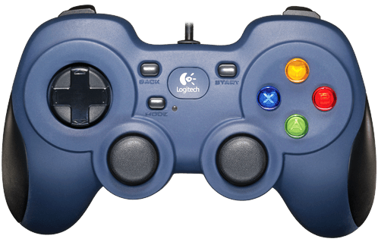

Truss Shot Preset

Manual acq. (Shooter must be up)

Left: High Goal from 1 point @18

Right: Mid Preset @ 48

Up: One Point/Truss @ 18

Down: Far preset @ 58.5

Button: Winch EStop

Button: Winds Winch

Unwind winch

Upper: Start Winch Cycle

None

Disable brake

Cancel Operation

Acquire

Home Position

Eject Ball

Lower: Shoot

Upper: Trim Up

Lower: Trim Down

None

Wind winch in a preset

Operator Joystick